ASIAN PARLIAMENTARY ASSEMBLY | 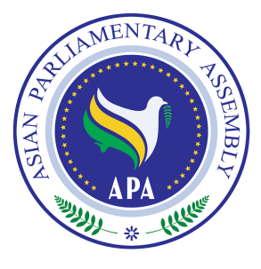
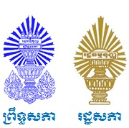
Tentative Working Program
National Assembly
First Executive Council Meeting
01-04 October 2017
Phnom Penh, Kingdom of Cambodia

Sunday, 01 October 2017
Arrival of Delegates
Arrive at Phnom Penh International Airport
Proceed to Sokha Phnom Penh Hotel and Residence

19.30 - 21.30 | Welcome Reception  Hosted by His Excellency Hon. Mr. CHHEANG Vun, Chairman of the Commission on Foreign Affairs, International Cooperation, Information and Media  Venue:
Monday, 02 October 2017
08.30 - 09.00 | Courtesy call on Samdech Akka Moha Ponhea Chakerei HENG Samrin, President of the National Assembly of the Kingdom of Cambodia and APA President (TBC)  Venue:
09.00 - 10.00 | Inaugural Ceremony  - National Anthem  - Welcome Speech by H.E. Dr. NGUON Nhel, Second Vice President of the National Assembly of the Kingdom of Cambodia and Chairman of the Organizing Committee  - Remarks by H. E. Mr. Mohammad Reza Majidi, APA Secretary General  - Opening Address by Samdech Akka Moha Ponhea Chakerei HENG Samrin, President of the National Assembly of the Kingdom of Cambodia and APA President (TBC)  - Photo session  Venue:
10.00 - 10.30 | Coffee Break
10.30 -13.00 | 1st Executive Council Meeting  Presided over by H.E. Dr. NGUON Nhel, Second Vice President of the National Assembly of the Kingdom of Cambodia and Chairman of the Organizing Committee  - Adoption of the Agenda and Election of Bureau  - Remarks by H.E. Dr. NGUON Nhel, Second Vice President of the National Assembly of the Kingdom of Cambodia  - Report of APA Secretary-General  - Consideration and Recommendation of the Draft Resolutions proposed by Standing Committee on Political Affairs  Venue:
13.00 – 14.00 | Praying time & working lunch
15.00– 17.00 | 1st Executive Council Meeting (Continued)  - Consideration and Recommendation of the Draft Resolutions proposed by Standing Committee on Economic and Sustainable Development Affairs  - Consideration and Recommendation of the Draft Resolution Proposed by Standing Committee on Staff and Financial Regulations  Venue:
17.00 - 17.30 | Coffee break
17.30 – 18.30 | 1st Executive Council Meeting (Continued)  - Consideration and recommendation of Draft Decision on mandatory visa issuance for delegates registered to participate in APA events by the Host Parliament.  - Nomination of APA Vice Presidents in 2018.  - Nomination of APA President after Turkey.
19.00 – 21.00 | Dinner hosted by H.E. Dr. NGUON Nhel, Second Vice President of the National Assembly of the Kingdom of Cambodia and Chairman of the Organizing Committee  Venue:
Tuesday, 03 October 2017
09.00 – 11.00 | 1st Executive Council Meeting (Continued)  - Consideration and Recommendation of the Draft Resolutions proposed by Standing Committee on Social and Cultural Affairs  Venue:
11.00 – 11.30 | Coffee break
11.30 – 12.30 | Preparation of the report of the meeting by the APA Secretariat
12.30 | 1st Executive Council Meeting (Closing)  - Adoption of the report of the meeting  - Any other matters  - Closing of the meeting
13.00 – 14.00 | Praying time & lunch break
15.00 – 18.00 | City Tour
Wednesday, 04 October 2017
Departure of delegates
*** END***

